**PEER REVIEWS**

**GDP2-Sec3-03(Jaya Kumar Saga, Shivaram Kothapally, Keerthi Muli, Rasagna Reddy Banda)**

<https://github.com/KeerthiMuli/Featured-Developer-Proposal>

1. **Kushal Katari**

**1. Verify if the app is successfully deployed to cloud (Heroku).**

The app Looks Great and the everyone’s data is included in the application so well that it is understandable.

Link : <https://featureddeveloper.herokuapp.com/#/home>

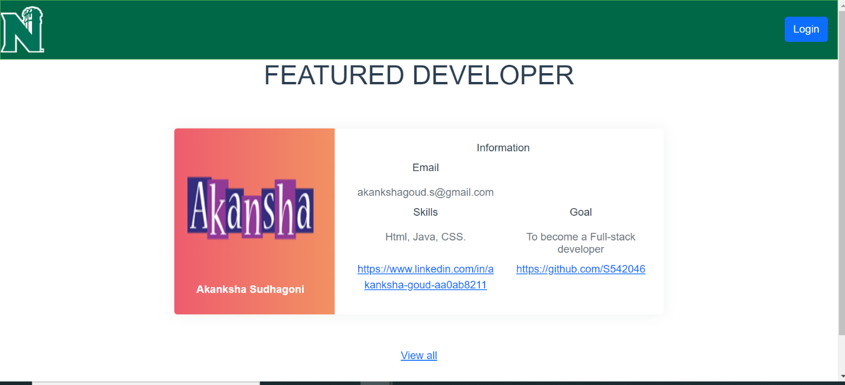

1. **Check for static code analysis (like Codacy).**

Checked the Codacy and is working well.

1. **Check For the issues.**

Here is the issues link: <https://github.com/KeerthiMuli/Featured-Developer-Proposal/issues>

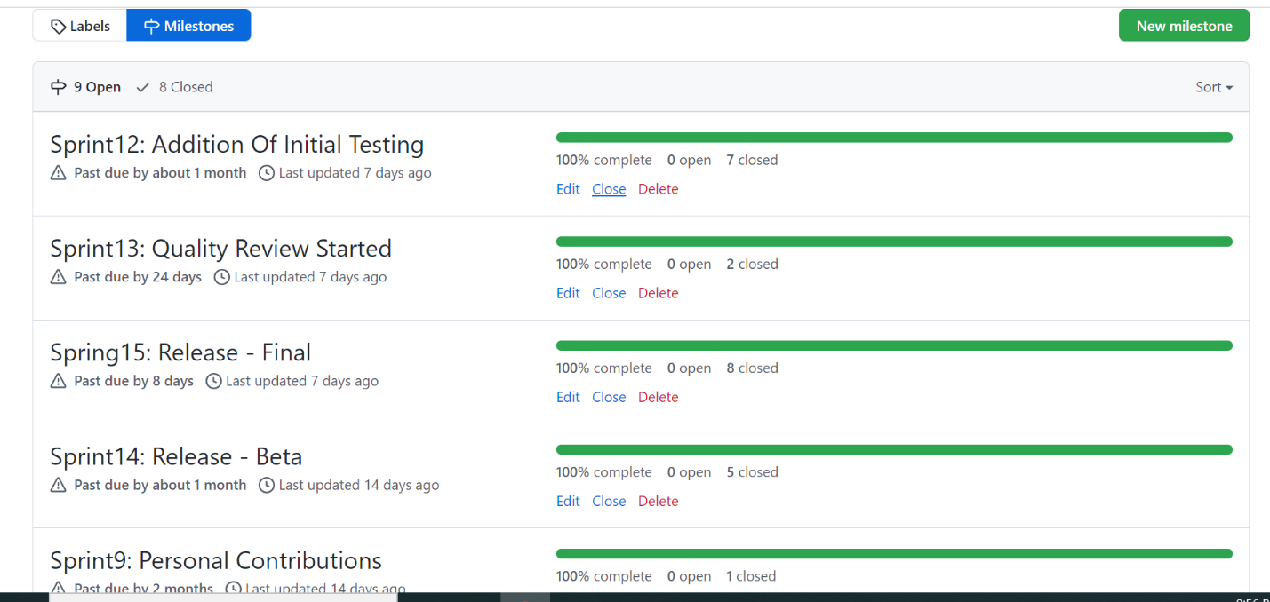

1. **Check for the Wiki**

The wiki looks great with active participation of all the members.

Here is the link to the wiki

<https://github.com/KeerthiMuli/Featured-Developer-Proposal/wiki>

1. **Check for the code coverage**

Code Coverage looks great.

<https://sagajayakumar.github.io/featured_developer_code_coverage/> \

1. **Check For the GitHub actions.**

GitHub actions are good.

<https://github.com/KeerthiMuli/Featured-Developer-ThreeB-Backend/blob/main/.github/workflows/maven.yml>

**2. Akhil Mallepally**

1. **Check for auth0 Authentication.**

They have worked on auth0 Authentication

Link : <https://dev-03byofah.us.auth0.com/u/login?state=hKFo2SAycHQ4dXpmMlpsMjkyTURmTmZkR3JzUE5pV1Vad1VIcqFur3VuaXZlcnNhbC1sb2dpbqN0aWTZIGZQMlhERWhyaXBnY2tzVy15VldveUNTdmhfQXpGYVhMo2NpZNkgaUhTRFhGQVJjWUFvT0xIZ29nTm1nU1NoMUF3WUdFcE8>

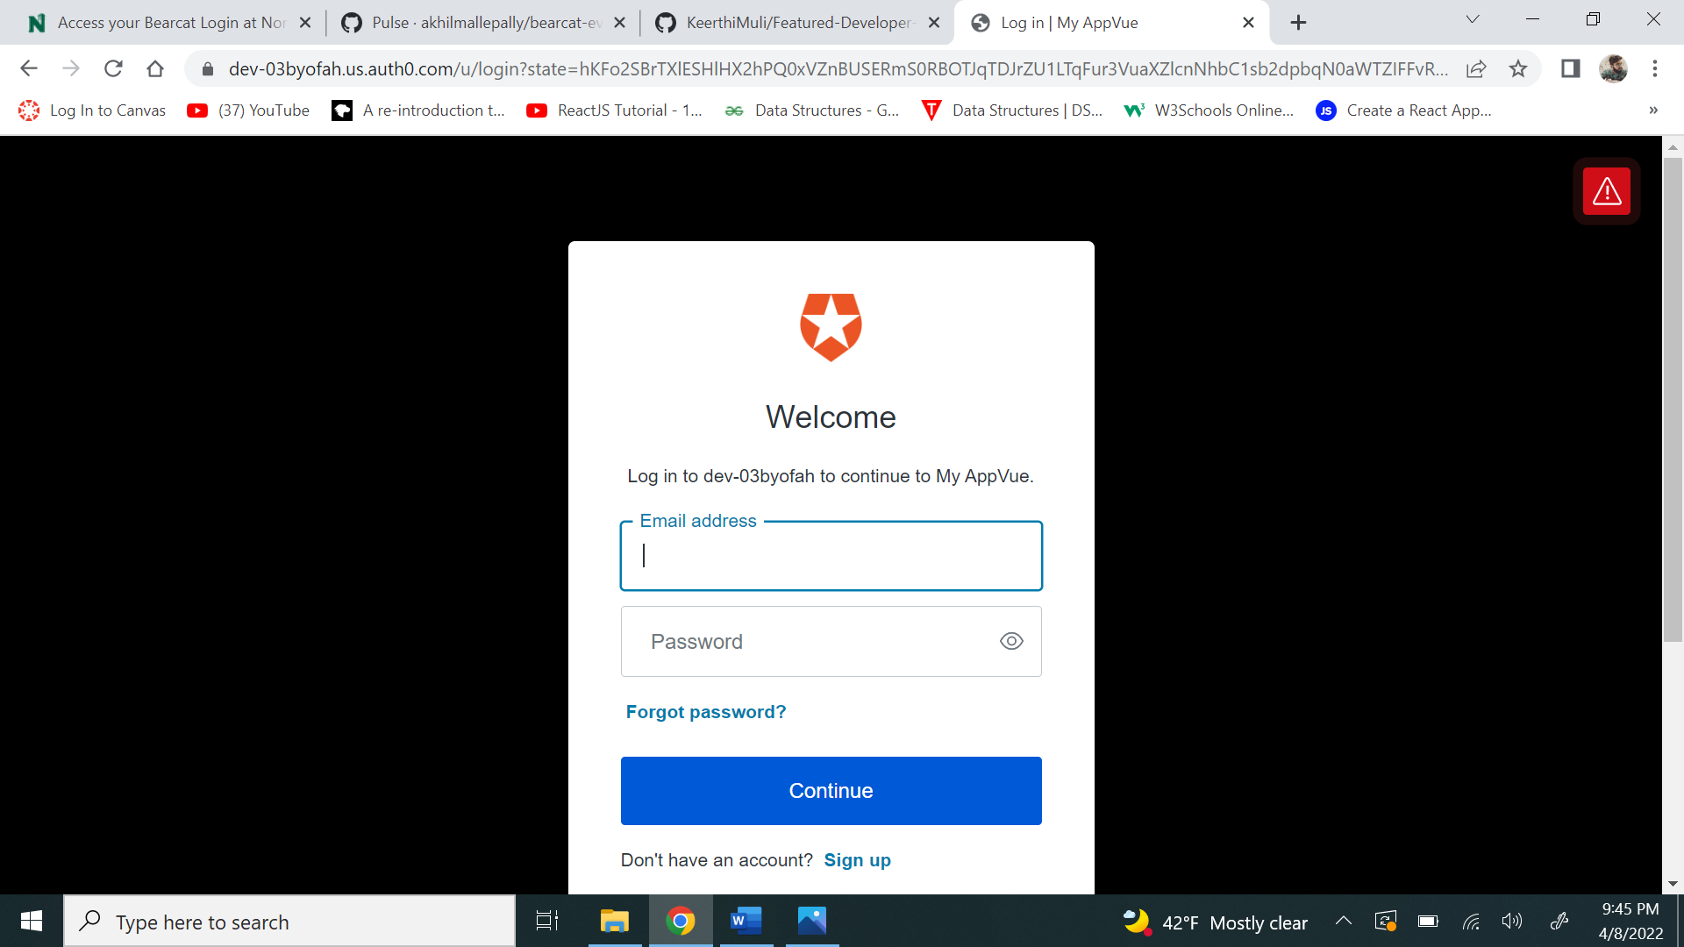

**2. Check for the Swagger API.**

The swagger is working well.

<https://featured-developers-threeb.herokuapp.com/swagger-ui/index.html?configUrl=/v3/api-docs/swagger-config>

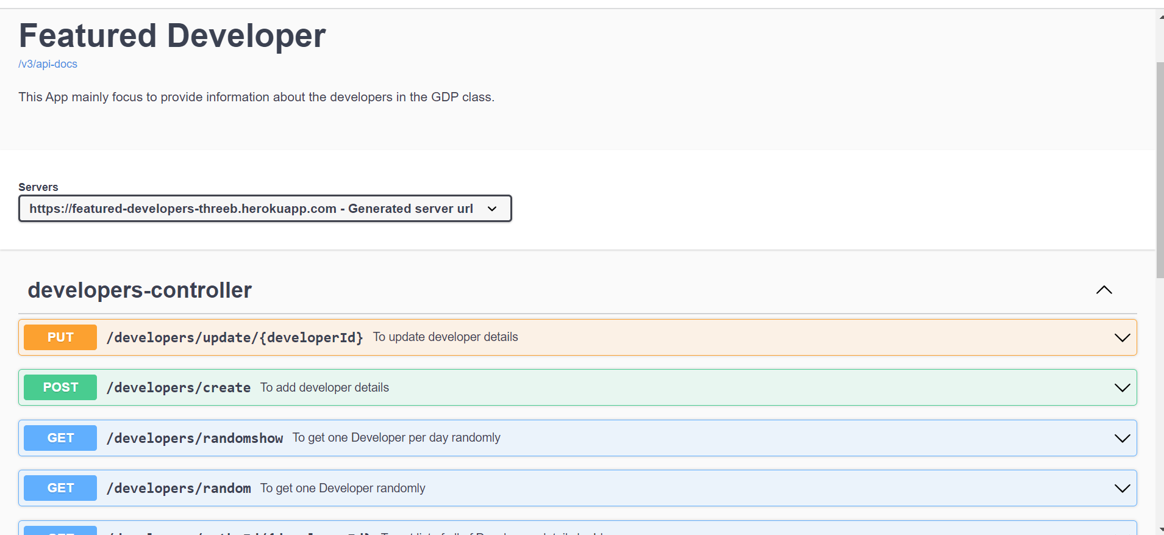

1. **Check for the code of the application.**

The code of the application is good.

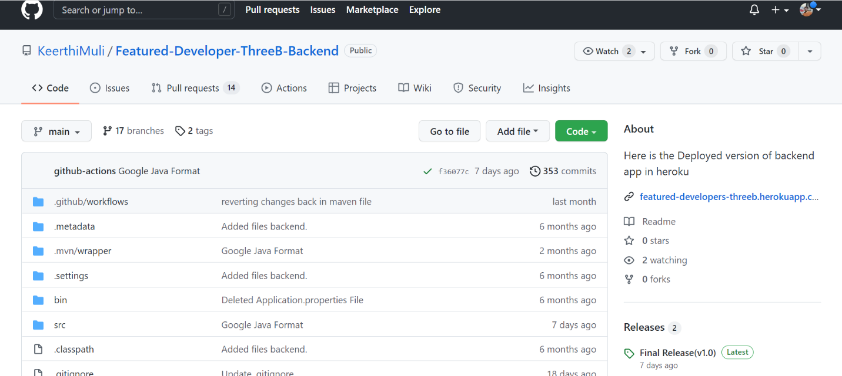

1. **Verifying implementation of test cases for the application.**

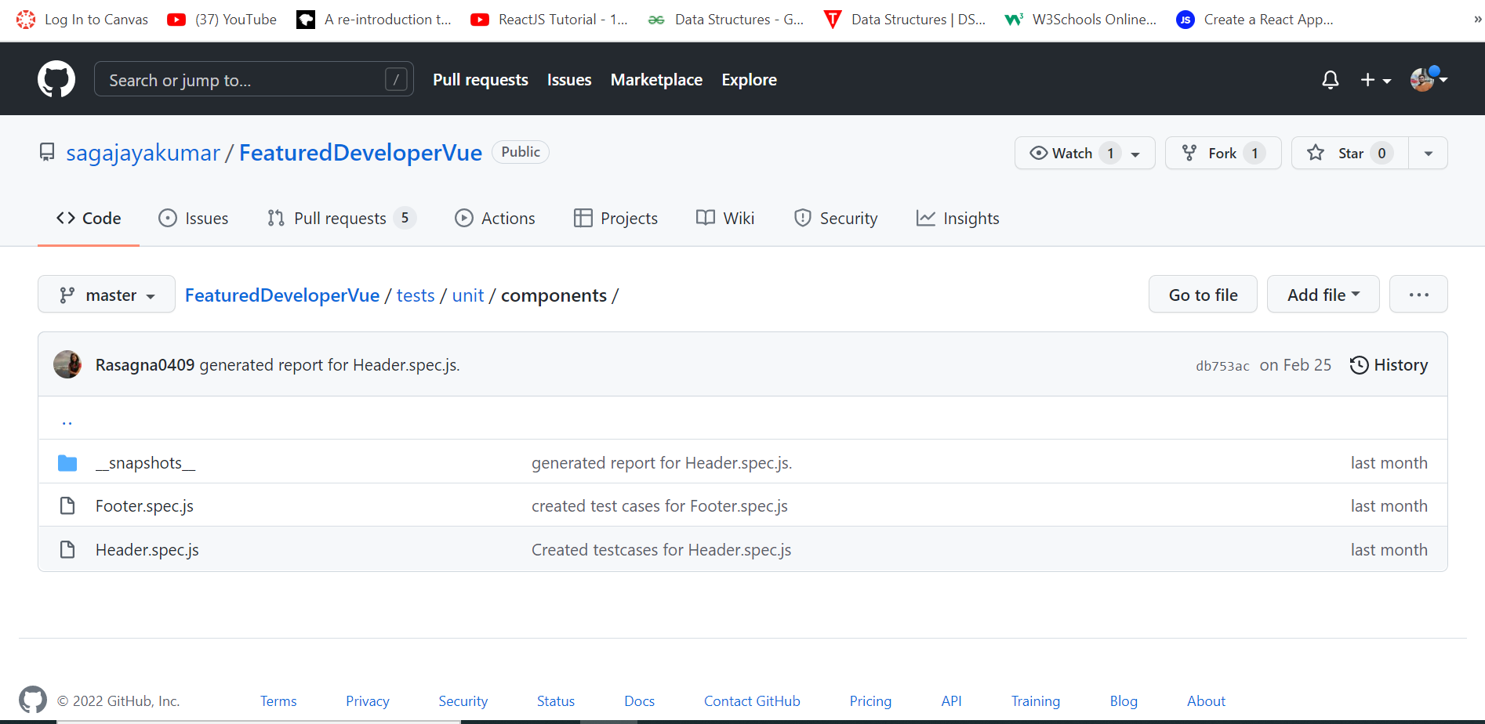

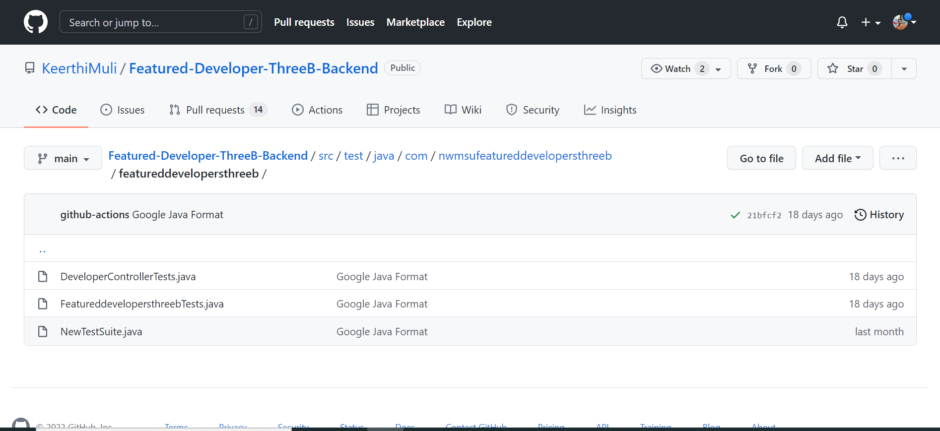

1. **Check for the GitHub page of the application.**

The GitHub page is well structured and included everything which is necessary to the project and everyone’s contribution is good.

<https://github.com/KeerthiMuli/Featured-Developer-Proposal>

1. **Check for the project Proposal.**

The project proposal is good with everything clearly stated.

[**https://github.com/KeerthiMuli/Featured-Developer-Proposal/blob/main/Proposal.md**](https://github.com/KeerthiMuli/Featured-Developer-Proposal/blob/main/Proposal.md)